Sefton ASD & ADHD Services
Clients/ Membership Application Form

Members Personal Details
Full Name.
Mobile Number.
Date of Birth.
Address:
What Hub are you Joining?
Please state so we can put things in place for you!
Social Events |  | Support Groups
1. Please tell us about your Autism or ADHD Condition
Please state so we can put things in place for you!
2. If you were to have a meltdown or an episode,
Please tell us how we can help!
3. Are you a danger to yourself or anyone else?
Please state so we can put things in place for you!
4. Do you consider yourself to have a Disability?
Please state so we can put things in place for you!
5. Do you take medication?
Please state what medication – dosage, times
6. Do you have any Dietary requirements we need to be made aware of?
Please state incase we was to have an event and provided food & Drinks
7. How did you hear about us?
Emergency/ next of kin Contact Details
Please provide us with the details of your next of kin in cause of Emergency
Name:
Telephone:

Relation to you?
Data Protection & Confidentiality Policy: Here at Sefton ASD & ADHD Services
We take our duty to protect your personal information and confidentiality seriously. We will store your information in a safe place, we won't share your information with anyone without your consent and if we do it will only be shared with the right people! Otherwise, we won’t share anything we don’t have too!

If you decide to leave our service our information will be stored on file for 1 month if you decide to return to our service. Once you have left Sefton ASD Services.we will discard your information the appropriate way. If you decide to come back to use at a later time that is ok but we will be asked to complete one of the application forms again!
Clients signature:
Signature: 🗶 Date:
*Office use only*
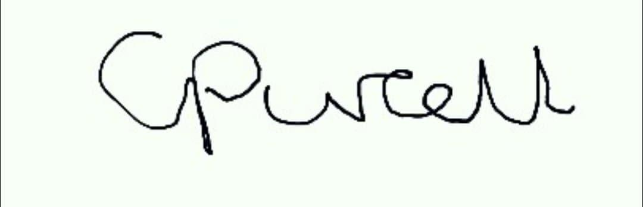
Manage Signature:
Signature: Date:
Staff/ Volunteer Signature:
Signature: Date:
Please return this Application form to seftonadhdasd@gmail.com
Would you like to be added to our WhatsApp group? YES/ NO

